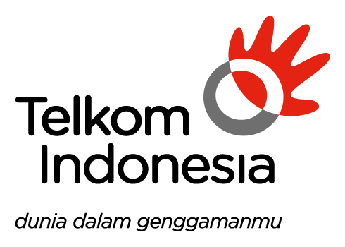

*DATA SHARING*

*TELKOM GROUP*

***TIDAK ADA DATA SHARING TELKOM GROUP***

***(MoM DG Council Meeting)***